How to Locate Student Emails and Phone Numbers

Faculty are able to obtain student cell and home phone numbers, in addition to email addresses in order to facilitate contacting students with important information. However, faculty cannot automate sending email to students from this location.

See Troubleshooting Email from Faculty Self-Service to send a mass email to your entire class roster.

To locate this information, follow the steps below.
Instructions | Illustrations
Navigate to svcc.edu | 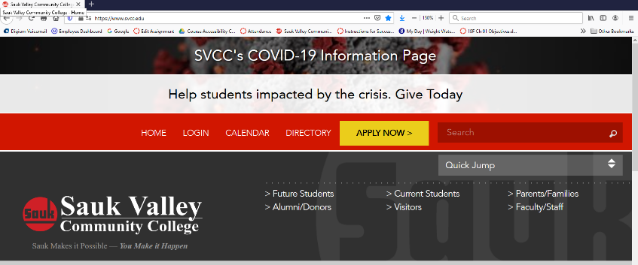
Select the Login menu

Scroll down to the Faculty and Staff area and select Faculty Self-Service | 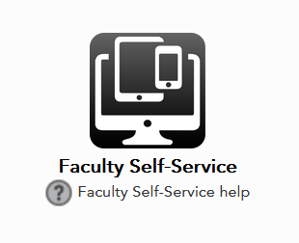
Login with your Sauk Login information | 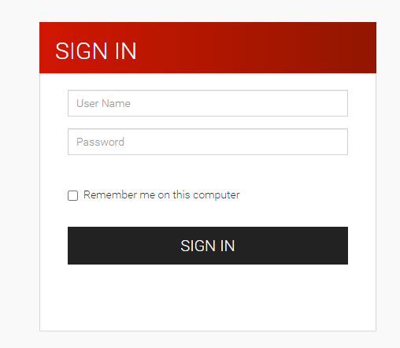
Select Class Roster Student Contact Information | 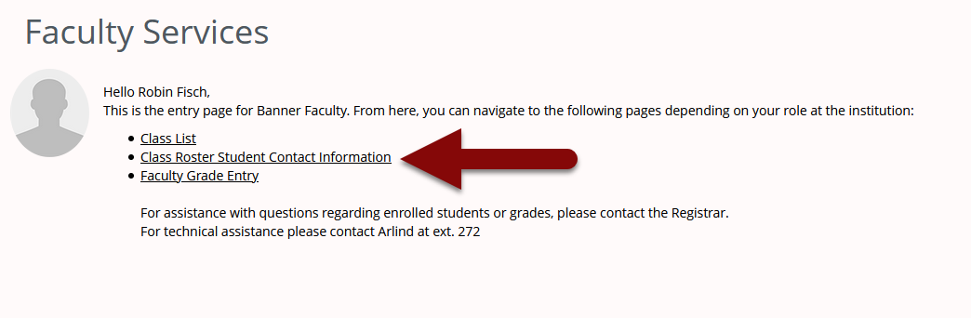
Select the current term from the Select Term drop down menu. | 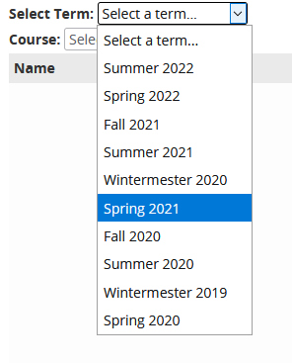
Select the course from the Select Course drop down menu. | 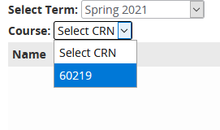
Locate the name of the student and the phone numbers adjacent and to the right. | 