ALIGNMENT WITH THE COLLEGE MISSION

College Mission
Sauk Valley Community College is an institution of higher education that provides quality learning opportunities to meet the diverse needs of its students and community.

College Vision
Sauk Valley Community College will be recognized as a benchmark institution of higher education that provides exceptional learning opportunities in response to the diverse needs of its students and community.

Program Mission
The Heating and Refrigeration program is supported in an institution of higher learning to:
- Provide exceptional technical learning opportunities which result in employment in a Heating, Refrigeration or Maintenance related field.
- Demonstrate, communicate and explore the necessity for technically trained student to pursue other business and communication skills and higher degrees achieved through general education and other degree opportunities offered at higher education institutions.

VIABILITY COMPONENT
The viability component focuses on quantitative analysis and the need for the program.

SECTION A: ENROLLMENT & RETENTION DATA for major field required courses
Resources: Annual Reviews, Items 1 & 2
Data Table 1
Operational Plans

- Describe a) the five-year enrollment trends, and b) results of the efforts to increase enrollment that were implemented since the last program review.
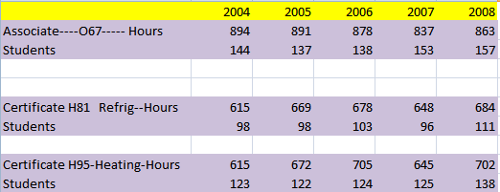
Associate and The two main certificates are shown above.
Certificate H83- Installer & Certificate H84-Entry Level Tech are certificates that were implemented prior to this 5 year review. To the best of our knowledge no students ever enroll in SAUK just for these two certificates. It is our opinion that these certificates are not enhancing the enrollment of this program. Students in these certificates are the same students who are working on the other certificates or associates. These have only served as papers that have been awarded to students by the college to the same students who are on their way to the larger certificates or degrees. These certificates are only causing more work and paperwork on the staff at the college and are not enhancing the program. It is our opinion that these certificates should be eliminated.

We would agree to keep the certificates if there is a monetary value to the college from the state because of these certificates.

- Credit hours from O67 (Associate), H81(Certificate) and H95 (Certificate) reflect stable and steady results for the last 5 years. Classes that were offered for Fall FY09 began full or over full.
- After reviewing the state employment records for this field in our area, we feel that we are training the correct number to match jobs and population. Classes were full or over full for the 2008 session. No exceptional or unusual efforts were made over the past five years to increase enrollment. That would require more sections and additional staff.
- We are making the assumption that it would not be wise decision to invest enough money in this program to make it a show place which would have reputation and marketability that would reach outside the district. That is the only way we would know to increase enrollment significantly and that would take substantial time and marketing money.

- Describe a) the five-year retention trends, and b) results of the efforts to improve retention that were implemented since the last program review.
  - The trend on retention is level. When enrollment is up—the student loss number is up---but the percentage appears to stay the same. Cyclical in direct relation to the economy for the most part.
  - Our efforts, which include, counseling, working around absences, working with students after hours, and helping students with late assignments does not seem to change the % of students not completing the program.
  - Retention rate is reflected at approximately 90 percent. This would indicate about 10 percent leaving without completing the program. Some of these are withdrawals but xperience reveals that there is a small number who gain enough skill to find a job in the field and then decide that they have no further need or desire to attend or complete the program.

- Describe what can be done to improve these trends during the next five years.
We are not sure if there is anything that can change this. The demographics of our older students create life situations that sometimes cannot be remedied. I.e. work, illness, family issues etc. Continue counseling to promote continued enrollment toward completion of program.

- Summarize activities to improve the trends discussed in this section in the operational plan and code as PA. Indicate below if activities will be included in the operational plan.
X Activities included in the operational plan
No activities included in the operational plan
SECTION B: PROGRAM COMPLETIONS & NEED FOR THE PROGRAM
Resources: Annual Reviews, Item 2
Data Table 2
Operational Plans

- Describe a) the five-year successful completion trends, and b) results of the efforts to improve the trends that have been implemented since the last program review.
- An average of 90 percent of the students in the 5 year period have completed the program.
- REPEAT INFORMATION ---- Retention rate is reflected at approximately 90 percent. This would indicate about 7 percent leaving without completing the program. Some of these are withdrawals but my experience reveals that there is a small number who gain enough skill to find a job in the field and then decide that they have no further need or desire to attend or complete the program.

- List any concerns identified in the Career and Technical Follow-Up Study and discuss solutions, OR if there were no concerns identified, indicate “None.”
    - I am still disappointed by the small number of people reached by the Follow Up Study.
    - Also it is disappointing to see so few responses from the people who are reached.

6 out of 7 responses are employed in the field.
2 out of 7 -28% went on and enrolled in other colleges.
6 out of 7 are working in the district.
Average is $14.79 per hour.
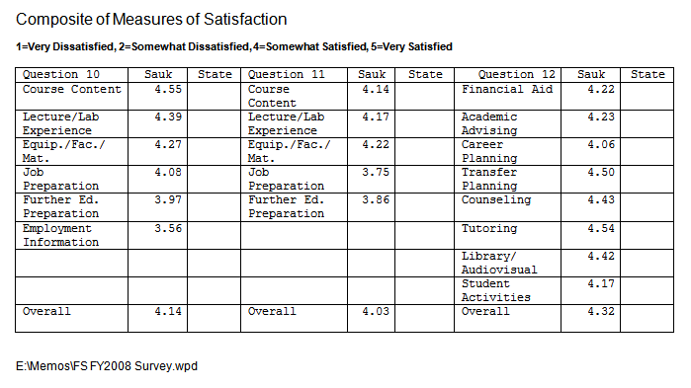We feel it is very important to point out that of the people surveyed we see extremely high marks of satisfaction. The only issue that is clearly apparent is that a career center would be of benefit to our program.

- Use data from the Illinois Workforce Development System http://iwds.state.il.us/iwdshome.html (click on Consumer Information and enter Sauk Valley Community College) which tracks WIA eligible students, to answer the following: AAS H81 H95
AAS H81 H95
Percent of students who complete the program: 66% 68% 66%
Percent of students employed after exiting WIA: 100% 100% 100%
Average starting hourly wage: $10 $9 $8

- Describe the occupational need for the program. (Create one or more tables that illustrate the projected occupational demand for program completers using information available on the Illinois Department of Employment Security website (www.ilworkinfo.com, click on Workforce Information Center, click on Quick Links; OR any other reputable source. Include all appropriate job titles. Be sure to site your data source.)

Illinois Depart of Employment Security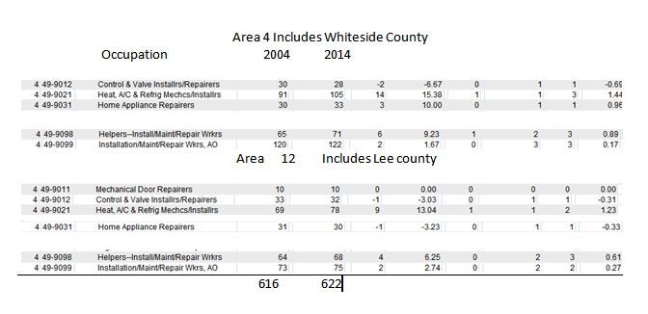

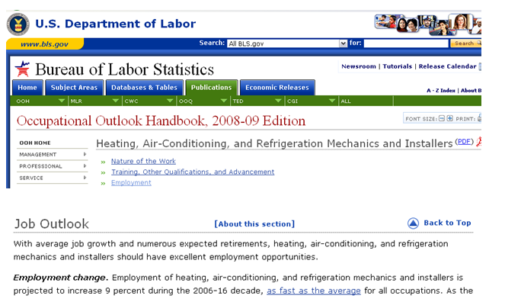

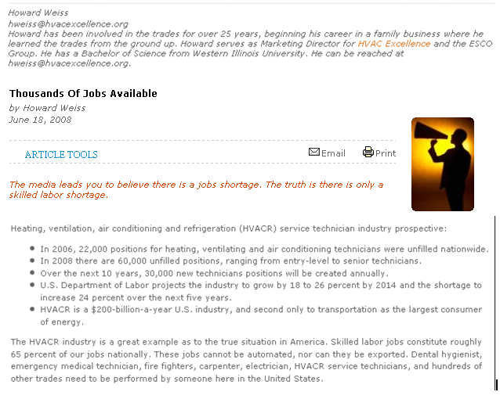
Director of HVAC Excellence National Certification Program
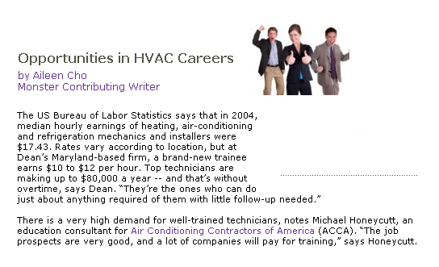
There is a very strong demand nationally----------------The demand is strong in our area but not as strong as nationally.

- Summarize the activities that the department will perform to improve the trends or respond to the issues identified in this section and code as PB. Indicate below if activities will be included in the operational plan.
This program could be better and produce better results with two changes. The Program desperately needs a lab assistant. The program needs new hands on trainers for refrigeration. We do not even have old hands on trainers for Refrigeration. We do have simulators on computers.
This would be a good place to point out in this review that the trainers that I had planned in the 2004 review (students were to build them) never materialized. Needed help – lab assistant – it was more than one person could teach and oversee. We also needed money for materials. The need for people trained in this field is not going away. Duplicate statement in #37 and add to op plan and/or equipment request form.

Whether any activities will be planned in the operational plan for these things will be the decision of administration---it has been explained a couple of times before.

X Activities included in the operational plan
No activities included in the operational plan

SECTION C: PROGRAM FINANCES
Resources: Annual Review, Item 3
Data Table 3
Operational Plans

- Describe a) the five-year income vs. expense trends, and b) results of the efforts to improve financial viability that were implemented since the last program review.
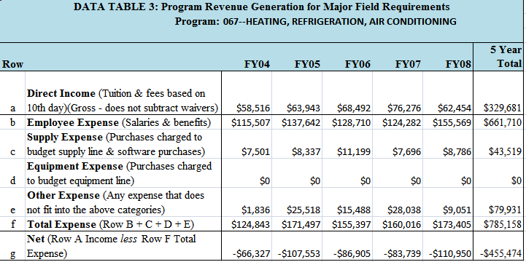

      - The income trend is level. The expense trend is a slight increase which we assume is the result of small pay increases, insurance cost and the increase in Other expense (whatever that is). Really need to get into this. May be an error or may be something that you can assist in correction. You will notice that there have been no expenditures for equipment over the past 5 years.
Item 10 asked for trends. We have given that. From the information given in the above report we are unable to assess why. Fees meeting disposable expenses?
Though Al Pfeifer gave explanation of what is included in these numbers, these are not the numbers that we as instructors deal with over a 5 year period. Therefore we find it impossible to give any in depth analysis to this information. We may have a better handle on what can be done to make the situation better or worse than people who do not work in the department but the best analysis of the above report could be done with administrative financial oversight.
      - Since we are unable to ascertain the whys of the above report, since we have lived within our budget, since our classes are full, since the community and population will not support more sections, and since more sections would add other staff and expenses, we have not implemented any new efforts over the past five years and do not know of any new efforts that can be implemented in the future to increase financial viability. The nature of technical classes ( lab expenses, and student to teacher ratio) will probably never support justification by finances or profit alone.

- Describe the results of the program’s efforts to go “green.”
Reclamation of refrigerants and refrigeration oils and other hazardous chemicals.

Recycling of aluminum, plastics and all other metals.

- Describe how the program’s financial viability may be improved.
REPEAT INFORMATION- Since we are unable to ascertain the whys of the above report, since we have lived within our budget, since our classes are full (16 – 20), since the community and population will not support more sections, and since more sections would add other staff and expenses, we have not implemented any new efforts over the past five years and do not know of any new efforts that can be implemented in the future to increase financial viability. The nature of technical classes (lab expenses, and student to teacher ratio) will probably never support justification by finances or profit alone. If change anything here make sure 10 b directly above is also changed.
Cyclical in direct relation to the economy for the mo

- Summarize activities to improve the program’s financial viability in the operational plan and code as PC. Indicate below if activities will be included in the operational plan.
Activities included in the operational plan
X No activities included in the operational plan

QUALITY COMPONENT
The quality component focuses on qualitative analysis and issues.

SECTION D: COURSE SCHEDULING

- Provide the program schedule by listing each required course by course number and indicating each semester in which it is planned to be offered.
Course Number | Year 1: Fall Semester | Year 1: Spring Semester | Year 2: Fall Semester | Year 2: Spring Semester
HRS 120 | X |  | X
HRS 130 | X |  | X
HRS 114 | X |  | X | X
ELT 160 | X . | X
HRS 112 |  | Design | Coursed | Missed
HRS 222 |  | Commercial | 1st two | Semesters
HRS 230 |  | ADV Heating
HRS 220 |  | DOM. Appliance
ELT 101 | House Wiring | House Wiring
ELT 262 |  | Motor Controls

- How many semesters should it take a full-time student to complete this program?
Certificate = 2 semesters (1 Year)
Associate = 4 semesters (2 years)

- During the past five years, have courses been offered and properly sequenced so a student could complete the program in the number of semesters specified above?
X Yes
No

- During the past five years, have scheduling conflicts been avoided by coordinating the days and times that courses are offered?
X Yes
No

- During the past five years, have scheduling conflicts been avoided by coordinating schedules with other required courses, outside of this area?
X Yes
No

- Describe scheduling changes that may be needed during the next five years and the rationale for the changes, OR indicate “None.”
None

- Summarize activities that the department will perform to correct scheduling problems and make future scheduling changes in the operational plan and code as PD. Indicate if activities will be included in the operational plan, OR if issues have been corrected, below.
Activities included in the operational plan
No activities included in the operational plan
X Issues have already been corrected
Sheet metal was moved from Spring to Fall and is no longer taught by Adjunct.
SECTION E: CURRICULUM: COURSE OUTLINES

- Have 100% of course outlines been reviewed and updated at least once during the past five years?
X Yes
No

- Are 100% of course outlines and syllabi aligned?
X Yes
No

- Summarize activities to correct course outline issues in the operational plan and code as PE. Indicate if activities will be included in the operational plan, AND/OR if issues have been corrected, below.
Activities included in the operational plan
No activities included in the operational plan
X Issues have already been corrected

SECTION F: CURRICULUM: ASSESSMENT
Resources: Annual Reviews, Item 5
Assessment folder, Program/Discipline Data

- List the program/discipline objectives that have NOT been assessed in this five-year period and indicate whether these will be assessed, eliminated, or replaced, OR indicate “All have been assessed.”
All program/discipline objectives have been assessed. They all have not made it to the assessment system but we will continue to increase assessment data entered in to the college wide system.

- Describe the results of the curriculum changes ensuing from assessment activities that were implemented since the last program review, OR indicate “None.”
The assessment process was very instrumental in helping us re-evaluate the program goals as well as course goals, state them on paper and share them with the students. No major course or program reconstruction took place because of assessment.

- Describe the status of any budget requests resulting from assessment activities since the last program review, OR indicate “None.”
None

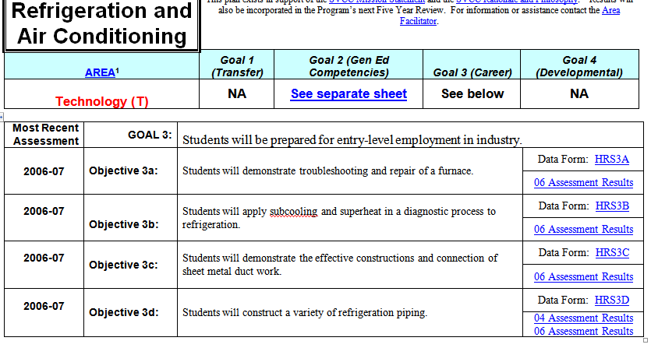
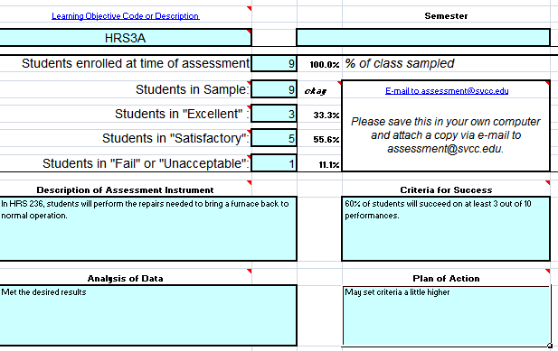

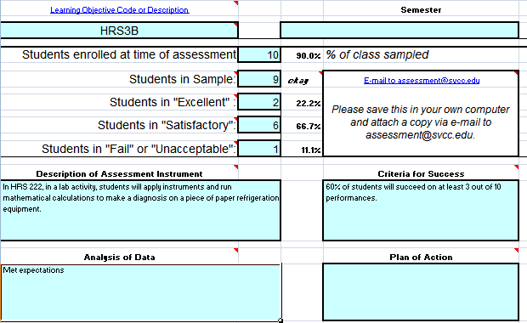
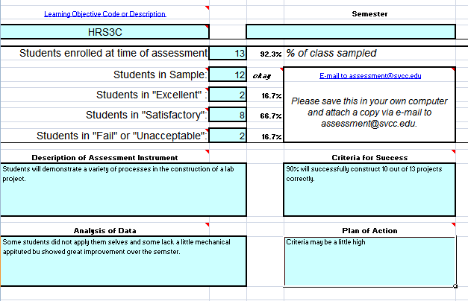

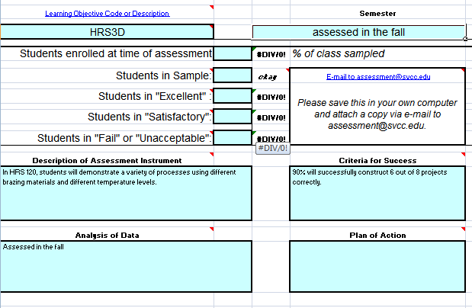

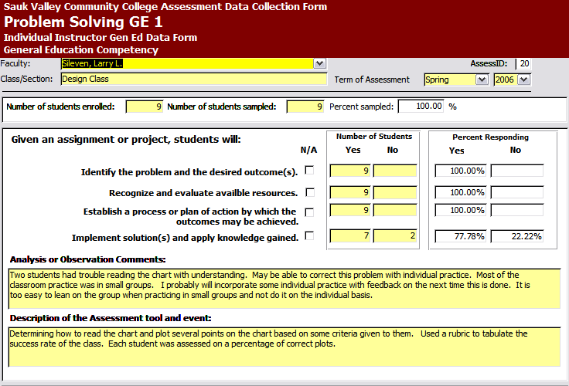

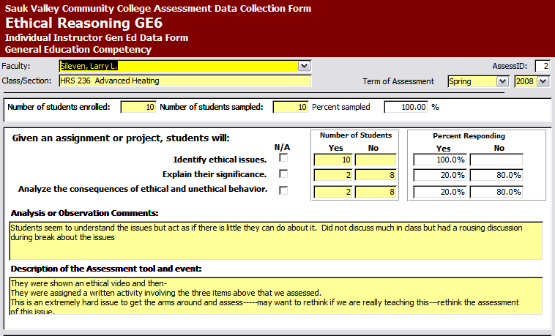

- Summarize activities related to assessment issues in the operational plan and code as PF. Indicate below if activities will be included in the operational plan.
X Activities included in the operational plan
No activities included in the operational plan

SECTION G: CURRICULUM: CURRICULAR CHANGES
Resources: Annual Reviews, Item 5
Assessment Summary Reports
Operational Plans

- Describe the positive or negative impacts of the curricular changes made during the past five years.
The only changes were the two minor certificates that were created at the suggestion of the recent academic dean. The impact was totally insignificant and we are recommending that they be eliminated.
We would agree not to eliminate these certificates if they have monetary value from the state to the college.

- Describe possible changes in employer or industry requirements that may be imposed on the program during the next five years, OR indicate “None.”
Employers will continue to encourage and see the need for employees to complete more technical training. Continued pressure for employees to obtain more technical training.

- Describe anticipated curricular changes that the department will propose during the next five years and the accompanying needs that will be required, or indicate “None.”
Curricular Changes | Equipment and/or Supply Needs | Facility Needs | Personnel and/or Training Needs
NONE

- Summarize activities that the department will perform to make curricular changes in the operational plan and code as PG. Indicate below if activities will be included in the operational plan.
X Activities included in the operational plan
No activities included in the operational plan

SECTION H: FACULTY

- Have 100% of full-time faculty participated in professional development during the past 5 years?
X Yes, skip to question 34
No, continue with question 33

- Describe what can be done to assure that 100% of faculty participate in professional development during the next 5 years?

- Will faculty need any specialized professional development in the next year?
X Yes, continue with question 35
No, skip to question 36

- Summarize the specialized professional development what will be needed, who will participate and estimated expenses.
Instructors will need to participate in special conferences and trade shows over the next five years to keep abreast of the changes in the industry, equipment, and the work force needs.
$1000.00 per year over 5 years= $5000.00
Another concern for the future of this program is to find instructors who have the HVAC skills, field experience and also possesses the academic experience and qualifications to operate in a higher education arena. HVAC people in the field typically do not go back to college, do not have degrees and certainly most often do not have work experience in a higher education setting.
Yes they can learn and be trained, but it will require a good bit of time on the part of the administration, area facilitator, and colleagues to shepherd them.

- Summarize activities that the department will perform so that 100% of faculty participate in professional development during the next 5 years in the operational plan and code as PH. Indicate below if activities will be included in the operational plan.

X Activities included in the operational plan
No activities included in the operational plan

SECTION I: EQUIPMENT AND SUPPLIES

- Identify current deficiencies in equipment, software, and/or supplies that negatively impact the program, OR indicate “None.”
Some of this was addressed in section B, item 9.
The installation of the welding lab adjacent to the furnace lab has created an unbearable situation. There is a problem with the exhaust situation in the welding lab. The exhaust that is being used is also the same fan and additional hood for the furnace room. The dirt from the welding lab covers the furnace room completely. The shelves, parts, floor, tools, furnaces and everything the HVAC students have to work on is covered with black soot. At times in the evening during class in room 1A1 the odor is strong enough to cause the students to complain to me about it.
This is larger than a maintenance issue. It has been a problem since the original engineering of the remodel of that area. And it is certainly larger than a housekeeping issue. Add to Op Plan to inform to get corrected
This would be unacceptable for any other program in the college and it needs to be corrected for the HVAC program.

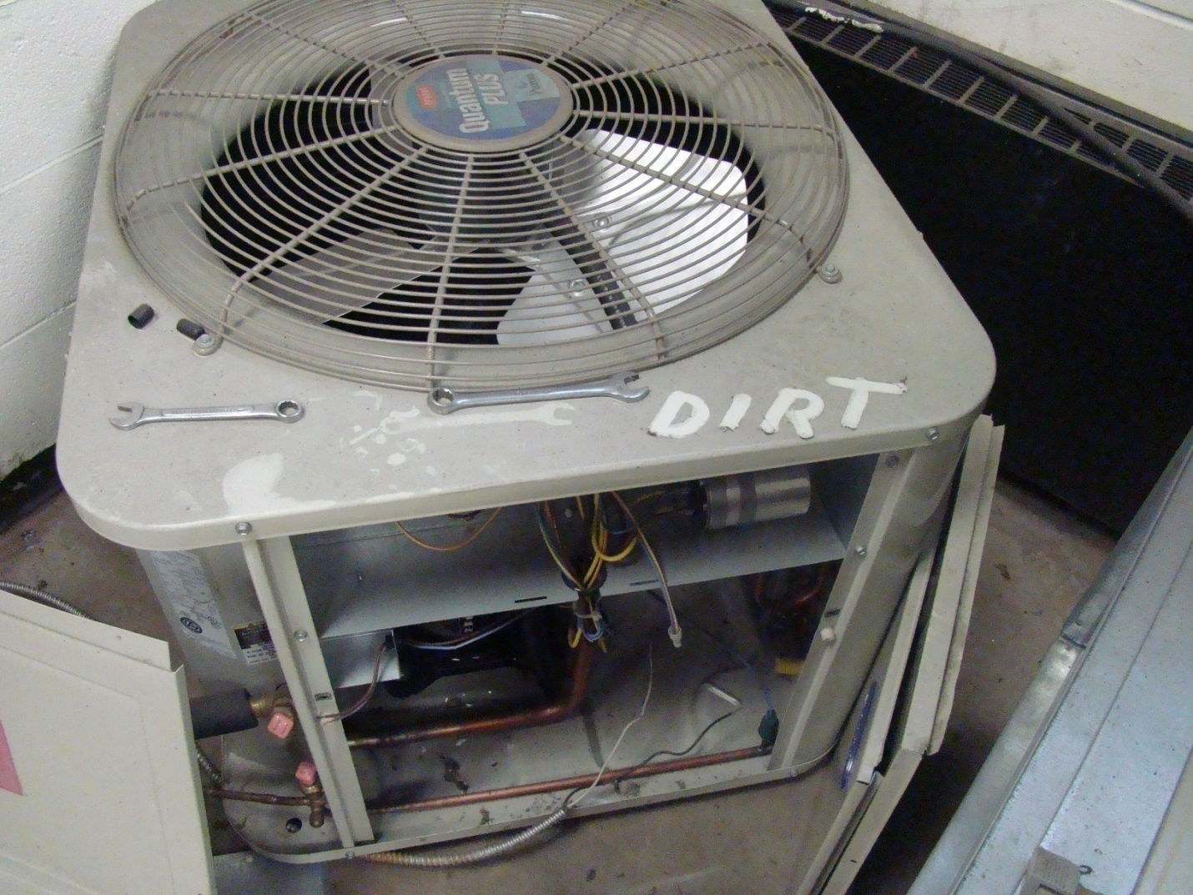

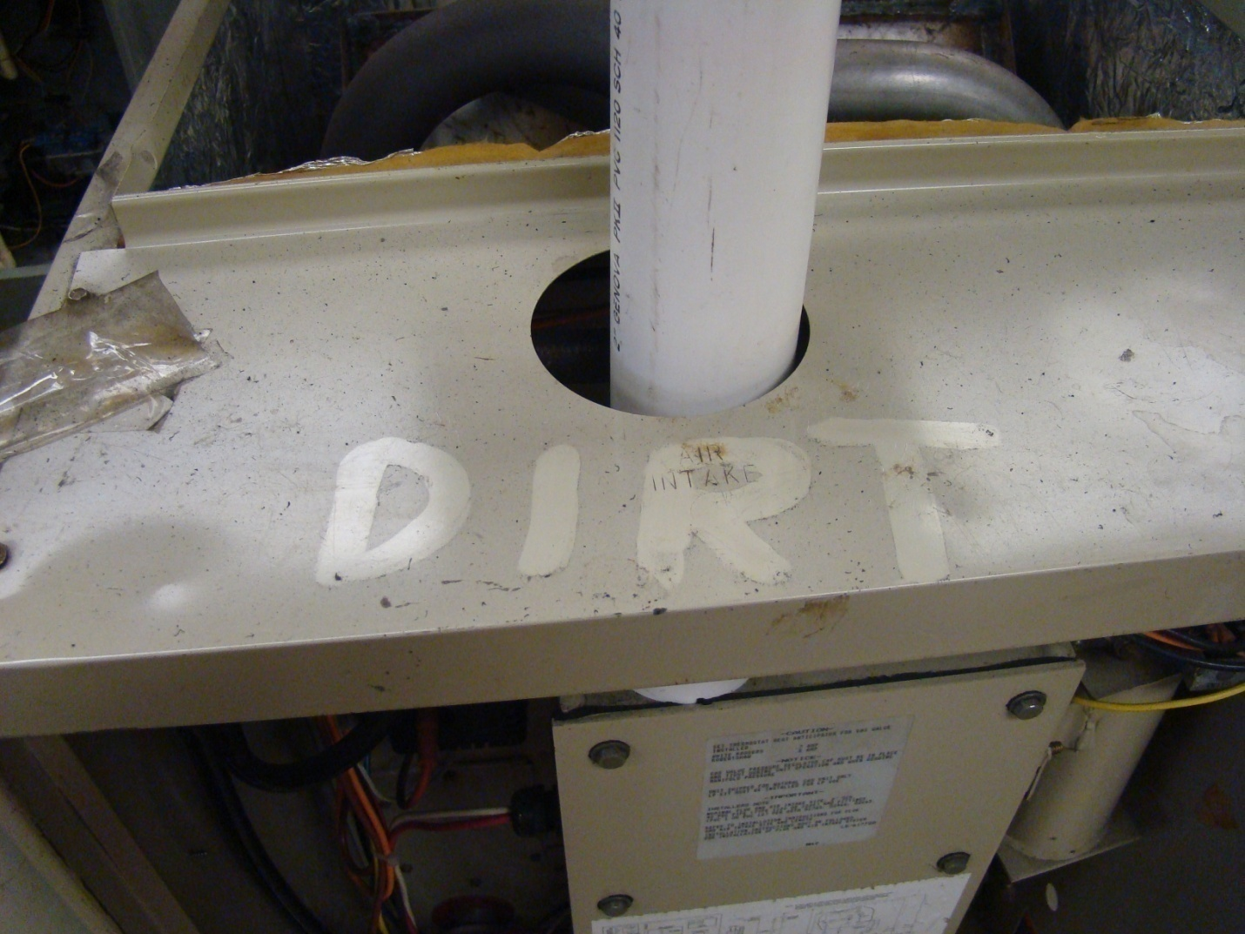

- Identify new and/or replacement equipment, software, and/or supplies which are anticipated during the next five years, with cost estimates, OR indicate “None.” Do not include items associated with the curriculum changes noted in Section G.
This has been addressed in section B, item 9.

- Summarize activities to acquire the needed equipment, software, and supplies in the operational plan and code as PI, AND/OR submit a completed Equipment Request Form. Indicate below if activities will be included in the operational plan, and if an Equipment Request Form is attached.
Depends if Administration decides to include it.
Activities included in the operational plan
No activities included in the operational plan
A completed Equipment Request Form accompanies this program review

SECTION J: SUPPORT SERVICES
Definition: College services that are specific to this program, which are utilized by students outside of the classroom (i.e. tutoring in the LAC, special materials in the LRC, etc)

- Describe the program specific support services that are currently available to students, OR indicate “None.”

None
Student support services
LAC
LRC
Administrative offices

- Describe gaps in the program specific support services that currently available and identify possible solutions, OR indicate “None.”
Refer to item above on career counseling/info Career & Tech follow-up pg 4None

- Describe any changes in the need for support services that are anticipated to occur during the next five years, OR indicate “None.”
None

- Summarize activities to expand or correct the gaps in support services in the operational plan and code as PJ. Indicate below if activities will be included in the operational plan.
Activities included in the operational plan
X No activities included in the operational plan

SECTION K: MARKETING
Definition: Systematic efforts aimed at attracting new students to the program.

- Describe how the program can be better promoted and marketed.
High school presentations to describe how the largest number of jobs in the world do not require 4 year degrees but require technical trade skills. This is not to discredit people who choose to attend four year programs after high school but should be carefully crafted to show how trades can be an option used as a tool to strengthen and pay for further steps in life and higher education without large college debts.

The presentation should also show two things:
- The statistics of people who begin to attend four programs after high school and do not complete but return to the training for technical skills and jobs.
- The statistics of people who choose not to attend college after high school, but after a few years of hard times in life return to the training for technical skills and jobs.
This would require a recruiter to train and better understand how this can be done. The importance of the trades and the growing number of shortages of people for these jobs is not being presented as an option as an interim way to climb the success ladder and the ladders of education without a large college debt to repay.
Not going forward with ones education is not an option in the world we live in today. Trades and service occupation skills are an excellent interim way to pay for college training to reach degree levels which protect your future and provide avenues to other opportunities later in life.
We have appreciated work of the Student Support Representative who has been to many college nights and recruited for HVAC in places where the program did not exist. Reports show that there has been a measure of success from these efforts.
Some team members on this committee feel that the paper mail outs worked well in the past and would help with marketing. Add to Op Plan to discuss with student services/recruiter

- Summarize activities to better promote and market the program in the operational plan and code as PK. Indicate below if activities will be included in the operational plan.
Should be a decision made by admissions and recruiting.
Activities included in the operational plan
No activities included in the operational plan

SECTION L: STUDENT INPUT
Definition: Systematic efforts aimed at student opinions and suggestions for improving the program.
Resources: Annual Review, Item 9
Operational Plans

- Describe what was gained from seeking student input since the last program review OR indicate “None was sought.”
Nothing was sought other than the student evaluations that are done by the institution every year. In summary, evaluations have been 80-90 percent positive in this program. There are always a few students who will give low ratings. We certainly look at those and review the comments to look for ways to improve.

- Summarize activities to obtain student input in the operational plan and code as PL. Indicate below if activities will be included in the operational plan.
Activities included in the operational plan
X No activities included in the operational plan

SECTION M: NON-STUDENT INPUT
Definition: Systematic efforts aimed at obtaining information regarding program content and improvement from informed sources other than students, for the purpose of keeping the program current and relevant.
Resources: Annual Review, Item 10
Operational Plans

- Describe what was gained from seeking non-student input since the last program review OR indicate “None was sought.”
Phone conversations with contractors in the community, former students in the area, and other facilities who use maintenance people is a good way to receive feedback on the quality of our student product. Phone conversations between the instructor and these community facilities occur an average of 10-12 times per month.
This also points out that this program would probably not be as effective without a full time instructor who could take these calls in a timely manner.
The current instructor is on campus an average of 8:00 AM to 9:30 PM four days per week.

- Summarize plans to obtain input from non-student sources in the operational plan and code as PM. Indicate below if activities will be included in the operational plan.

Activities included in the operational plan
X No activities included in the operational plan

SECTION N: NEED AND GROWTH POTENTIAL

- What is the projected level of need for the program, during the next five years?
X Growing need
X Level need
Declining need

- List the top five priorities to strengthen the program during the next five years.
    - Professionalize and modernize the area with décor & equipment.
    - Lab Assistant
3. High school presentations by qualified representatives of the trades and recruiters.
4. Hands on Refrigeration trainers
5. More involvement from community employers

- Summarize plans to address the top five priorities in the operational plan and code as PN. Indicate below if activities will be included in the operational plan.
Administration will decide what will be included in the operational plan.
Activities included in the operational plan
No activities included in the operational plan

CAREER AND TECHNICAL EDUCATION PROGRAM REVIEW SUMMARY REPORT
Required ICCB Program Review Report
Sauk Valley Community College Academic Year 2008 - 2009

Program Identification Information
6-digit CIP | 470201

Degree Type  03 – AAS  20 – Certs. 30ch >  30 – Certs. <30ch | 03 – AAS  20 – Certs  30 - Certs

Program Title | Heating, Refrigeration and Air Conditioning (0067)  Heating Certificate (0H95)  Heating, Refrigeration and Air Conditioning Installer Certificate (0H83)  Refrigeration (0H81)  Heating, Refrigeration and Air Conditioning Entry Level Technician Certificate (0H84)

Action
X Continued with minor improvements
⁭ Significantly modified
⁭ Discontinued/Eliminated
⁭ Placed on inactive status
⁭ Scheduled for further review
⁭ Other, please specify:

Improvements & Rationale for Action

Based on the state numbers of jobs in the area, we feel we are training the correct number of students for the future jobs in this profession for this area. The classes have been full or mostly full and more therefore enrollment would require more sections and more staff and more equipment. We do not feel the community numbers will support that attempt to increase. The program is strong but the program is not without some needs. We do not believe that technology programs of this nature can be justified by dollars or profit alone due to student teacher ratio needed for success.
The schedule has been changed some to allow the full time instructor to cover HRS 114 classes that were being covered by adjunct.
There are some equipment, staff and logistics needs in the program that will be addressed as the administration deems that the budget allows. Some of those needs have existed since the last program review but the administration could not prioritize those needs due to budget constraints.

Principle Assessment Methods Used in Quality Assurance for this Program
X Standardized assessments
X Certification and licensure examination results
⁭ Writing samples
⁭ Portfolio evaluation
⁭ Course embedded questions
X Student surveys
⁭ Analysis of enrollment, demographic and cost data
⁭ Other, please specify:

Statewide Program Issues (if applicable)

We do not see any statewide issues regarding this program at this time. All sources show a shortage of workers in this profession and the shortage is growing. The profession is becoming more technical and the demand for more training is paramount. The only “fly in the ointment” for SAUK is that the shortage is nationwide and not necessarily area wide.

Best Practices Report
Optional ICCB Program Review Report
Sauk Valley Community College Academic Year 2008 - 2009

Title of Best Practice

Programmatic Area
⁭ Academic Discipline
X Career and Technical Education
⁭ Cross-Disciplinary
⁭ Student & Academic Support Services

Description of the innovation/best practice (150 word limit)

What are the results/measurable outcomes?

Contact Information
Sauk Valley Community College
Name & Title:
Phone Number:
E-mail Address:

FINAL NOTES:
- Complete the Program review using this document as a template. Do not use alternate formats.
- The Program Review is due December 1, 2008.
- The Program Review should be submitted as an e-mail attachment to:
  - The program’s administrative supervisor, and
  - The chair of the Program Review Committee, Janet Lynch.
- The names of the Program Review Team are to be included in the electronic version.
- Print the Signatures and Approval page and obtain signatures from all team members and submit to the chair of the Program Review Committee, Janet Lynch.
Checklist | Supporting Documents to be submitted with this Review
YES | Assessment Summary Report (referenced in Section F)
YES | Data Tables 1, 2, & 3 (most recent tables only)
N/A | Equipment Request Form (referenced in Section I)
YES | ICCB Program Review Report
N/A | ICCB Program Review Report: Best Practices (optional)
N/A | FY09 Operational Plan (addendum to original plan)
N/A | Personnel Change Request Form (referenced in item 7)
 | Signatures and Approval 1) Type names of the team conducting this program review and include with the electronic submission; 2) Print the page and obtain each team member’s signature; 3) Submit the signed page to the chair of the Program Review Committee, Janet Lynch.

SIGNATURES and APPROVALS

Names and Signatures of the Program Review Team Add lines if needed
Signatures indicate that team members concur with the findings of the program review
Names (Indicate chair/co-chairs) | Signatures
Larry Sileven, Chair
Scott Gillihan
Steve McPherson
Loren Neimeyer
Tom Breed

Program Review Committee
This Program Review is complete and acceptable.
This Program Review is complete but the conclusions are not fully substantiated.
This Program Review is incomplete and unacceptable.
Comments are attached (optional)
Program Review Committee Chair/Co-Chair
Date
Program Review Committee Co-Chair
Date

Administrative Approvals
Administrative signatures indicate an acceptance of the program review.
Program Administrator
Academic Vice President
President

