FIRE
Extinguisher program – prevention plan – maintenace plan
sauk valley community college – 173 IL Rt 2 dixon IL, 61021
2018
  - Table of Contents

Subsection Page No.
Fire Extinguisher Program ………. 2
Fire Prevention Plan ………. 4
Fire Protection Equipment Maintenance Plan ………. 6
  - Fire Extinguisher Program

Overview: The requirements of this section apply to the placement, use, maintenance, and testing of portable fire extinguishers provided for the use of employees

OSHA Reference: 1910.157(e) (2) - Portable extinguishers or hoses shall be visually inspected monthly.

OSHA Reference: 1910.157(e) (3) - The employer shall assure that portable fire extinguishers are subjected to an annual maintenance check. Stored pressure extinguishers do not require an internal examination. The employer shall record the annual maintenance date and retain this record for one year after the last entry or the life of the shell, whichever is less. The record shall be available to the Assistant Secretary upon request.

Monthly Inspection: SVCC Security personnel inspect campus fire extinguishers on a monthly basis. Inspections are recorded and retained both in the Security office (1C04) and in FileBound.
- Inspections include the following criteria:
- Device is in a proper location
- Containment unit/ device holder is free from damage and secures extinguisher in place
- Device has no apparent damage or signs of being used/tampered with
- Pressure gauge has a satisfactory reading
- Annual Inspection tag is attached and current

- Attached is example documentation of Security Monthly inspections

Annual Inspection: Company One Fire Suppression & Safety Solution is contracted to provide the annual recertification of fire suppression equipment. Documentation is maintained in the Facilities Office (1C12).

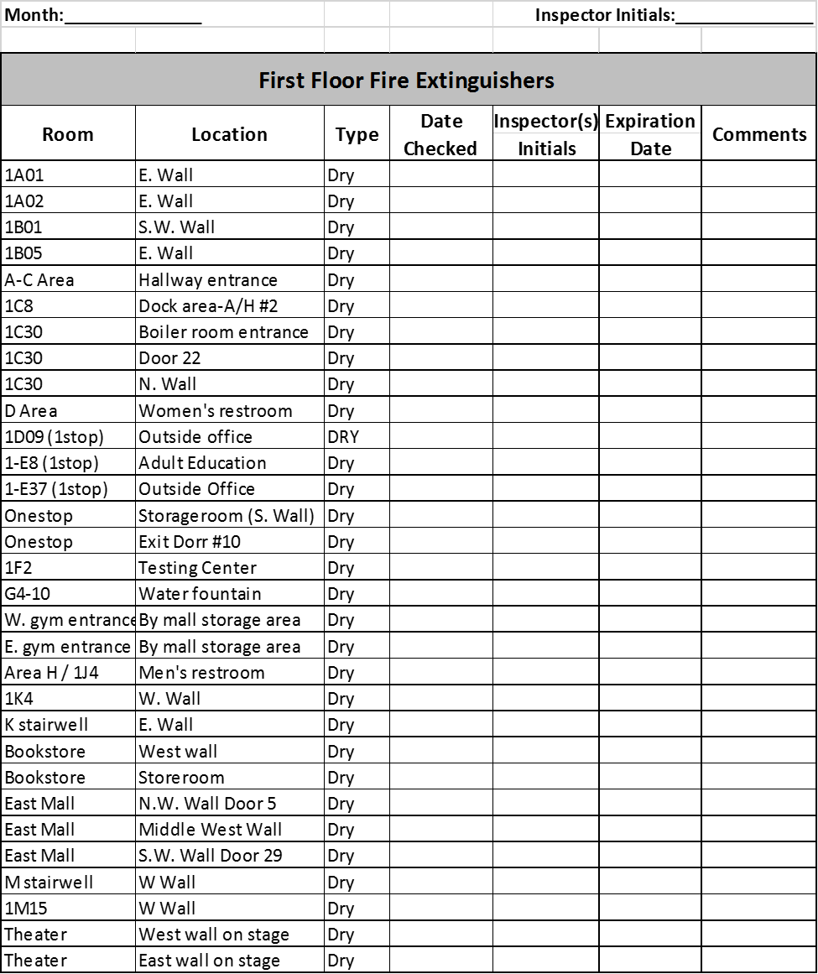

*Example of Security Monthly Fire Extinguisher Inspection

Fire Prevention Plan

Overview: A fire prevention plan must be in writing, be kept in the workplace, and be made available to employees for review.

Notes: A complete written fire prevention plan can be attained in office 1C04, or by visiting the Security page on svcc.edu. Brief instructions are also posted in various locations throughout the building

OSHA Reference: 1910.39(a)
Fire Hazard Analysis
Frequency | Rare occurrence
Magnitude | The greatest danger is smoke inhalation by people in the building, which could result in mild to severe injuries, even death. The materials used in the building construction will help to contain a fire and prevent it from spreading.
Intensity | Depends on what burns and the location of the fire
Location/spatial extent | A fire should be contained within a limited area of the building if doors are closed.
Duration | Variable from a few minutes to hours
Seasonal pattern | None
Speed of onset | Variable from a few minutes to hours
Availability of warning | Someone discovering a fire starting  Smoke detectors in main areas  Fire alarm activation stations
Vulnerabilities | - Overloaded circuits (most likely caused by personal electrical items such as space heaters)  - Chemical storage areas
Response to vulnerabilities | - Shut down air handlers if a fire breaks out (automatic)  - Maintain proper signage in chemical storage areas
Effect on institution and people | In case of a fire:  - All areas of the building will be evacuated  - Everyone will be kept out of the building until it is determined that it is safe to return
Effect on community | None
Response capabilities | - Fire extinguishers  - Fire alarms (audio siren and visual strobe light)  - Smoke detectors
MOUs | None. Fire protection is provided through Lee County emergency services that can be contacted by dialing 911 if needed.

Emergency Procedure: Fire
Evacuation

Incident commander
For most situations requiring evacuation or sheltering, the incident commander will be:
Primary: Director of Facilities
Alternate: Assistant director of Facilities or
Night Administrator or
Security

Evacuation procedures
- All people will be directed to use the stairs
- If it safe to use the elevator, it should be reserved for use by individuals who are not physically capable of walking down the stairs
- Radio holders will go to their assigned areas of the campus to assist with procedures
- Security personnel will go to assigned locations to assist individuals with disabilities
- Bullhorns should be carried by those assigned to do so

During an evacuation, everyone should…
- Move at least 500 feet from the building and into the East and/or North parking lots. 500 feet is the approximate distance to the parking lot area
- College staff should help move people away from the building
- Do not attempt to leave the campus or move their cars as traffic may block entering emergency vehicles
- During inclement weather or during freezing temperatures, evacuees may be directed to T1, T2, or T3 until the all clear is given
- The telephone extension 257 in the grounds building will be used to communicate with the 911 dispatcher, and will staffed by one of the following:
  - Director of Facilities
  - Assistant director of Facilities
  - The director’s designee

Emergency Notification: SVCC’s Emergency Intercom system will be utilized in the event of a fire for communication and direction purposes. It is maintained and inspected by both Security and Maintenance staff. Strategic stairwells are also identified and equipped with Evac-u-Trac equipment to be used by Security Personnel to assist occupants down stairs
Training/Drills: Two campus-wide Fire drills are conducted each year including Incident Management personnel, administration, faculty, staff, students, and visitors. These drill mirror real fire operations, utilizing the emergency intercom system and the mobilization of our Incident Management team.

  - Fire Protection Equipment Maintenance Plan

Overview: Fire Protection Equipment (Sprinkler system, Alarm panels, etc.) are to be inspected, tested, and maintained to ensure readiness in the event of a fire.

OSHA Reference: 1910.39 (Subpart L)

Definitions:
- Inspection: A visual examination of a system to verify that it appears to be in operating condition and is free of physical damage.
- Test: A physical trying or operation of a system, or part of a system, to ensure or prove that it is functioning properly, as intended, or to an acceptable standard of operation.
- Maintenance: The work performed to repair and/or maintain equipment in operable condition.

Monthly preventative maintenance – SVCC Security personnel regularly inspect fire suppression equipment, ensuring it is free from physical damage.

Quarterly Inspection/Test – Ahern is contracted to provide an inspection/test every 4 months of the fire suppression system. This includes:
- Visual inspection
- Function testing of various equipment
- Pump operation
- Pressure gauging
- Water flow monitoring
- Alarm system operation

Annual Preventative Maintenance – Ahern is contracted to do a thorough test of the fire suppression system to ensure proper function

SVCC Security and Administrative Staff conduct four emergency drills each year that include a complete activation of the alarm system and emergency intercom to test for proper function

*Documentation on SVCC Security inspections can be found in office 1C04
*Documentation on Ahern inspections can be found in office 1C12

